

**THE INTERNATIONAL SCHOOL BANGALORE**

**ENTRANCE ASSESSMENT**

**SUBJECT: CHEMISTRY**

**GRADE: 11**

**TOTAL MARKS: 25 MARKS**

**TIME ALLOWED: 30 MINUTES**

**TEST DATE:**

**APPLICANT’SNAME:**

**INSTRUCTIONS:**

* No Calculators are allowed.
* All questions are compulsory, please use a pen.
* Please circle only one correct answer from the given options.
* Please write your answers on the space provided on the question paper.
* Return the question papers and the rough sheets to the invigilator before leaving the hall.

**This Question Paper consists of (6) printed pages including this cover page.**

**1.** Impurities change the melting and boiling points of substances. Sodium chloride is added to a sample of pure water. How does the addition of sodium chloride affect the melting point and boiling point of the water?

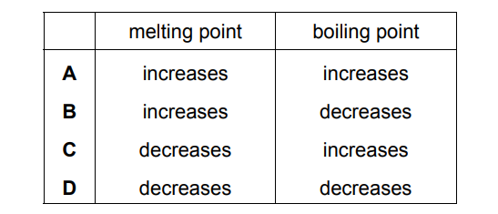

**2.** Which chromatogram shows how the Rf value of a substance is calculated?

**3.** Which statement describes metallic bonding?

A The attraction between a lattice of negative ions and delocalised protons.

B The attraction between a lattice of positive ions and delocalised electrons.

C The attraction between delocalised protons and electrons.

D The attraction between oppositely charged ions.

**4.** Calcium carbide, CaC2, reacts with water to form ethyne, C2H2, and calcium hydroxide. The equation for the reaction is shown.

**CaC2(s) + 2H2O(l) → C2H2(g) + Ca(OH)2(s)**

Which volume of ethyne is produced when 6 g of water react completely with calcium carbide?

A 4 dm3

B 8 dm3

C 36 dm3

D 72 dm3

**5.** Nitrogen forms a nitride ion with the formula **N3–**. Which particle does not have the same electronic configuration as the nitride ion?

A Al 3+ B Cl – C Na+ D O2–

**6.** Which statement about electrolysis is correct?

A Electrons move through the electrolyte from the cathode to the anode.

B Electrons move towards the cathode in the external circuit.

C Negative ions move towards the anode in the external circuit.

D Positive ions move through the electrolyte towards the anode during electrolysis.

**7.** Which statement about fuels is correct?

A Heat energy can only be produced by burning fuels.

B Hydrogen is used as a fuel although it is difficult to store.

C Methane is a good fuel because it produces only water when burned.

D Uranium is burned in air to produce energy.

**8.** An example of a redox reaction is shown.

**Zn + Cu2+ → Zn2+ + Cu**

Which statement about the reaction is correct?

A Zn is the oxidising agent and it oxidises Cu2+.

B Zn is the oxidising agent and it reduces Cu2+.

C Zn is the reducing agent and it oxidises Cu2+.

D Zn is the reducing agent and it reduces Cu2+.

**9.** Which statements about the trends across a period of the Periodic Table are correct?

1 Aluminium is more metallic than sodium.

2 Beryllium is more metallic than carbon.

3 Boron is more metallic than lithium.

4 Magnesium is more metallic than silicon.

A 1 and 2 B 1 and 3 C 2 and 4 D 3 and 4

**10.** The fractional distillation of petroleum is shown. Which fraction contains hydrocarbons with the longest chain length?

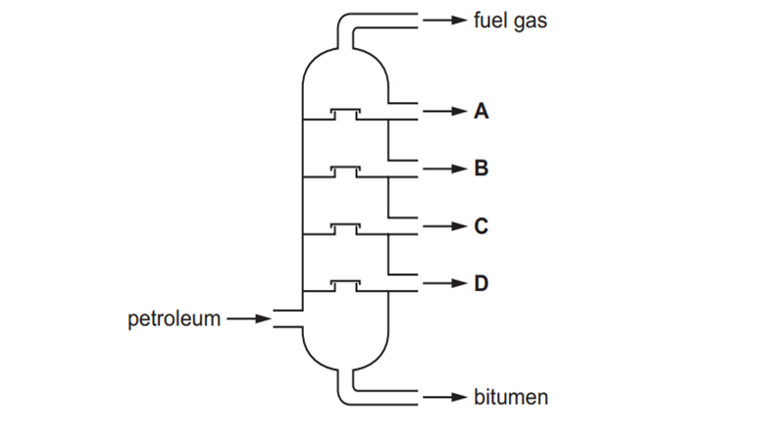

**11.** Nitrogen, hydrogen and ammonia gases are placed inside a container. The container is then sealed. After some time, an equilibrium forms.

**N2(g) + 3H2(g) ↔2NH3(g)**

Which statement describes the equilibrium in this container?

A The amount of ammonia remains constant from the moment the container is sealed.

B The amounts of ammonia, nitrogen and hydrogen in the container are always equal.

C The rate of formation of ammonia is equal to the rate of decomposition of ammonia.

D The rate of formation of ammonia is faster than the rate of decomposition of ammonia.

**12.** In reaction R, 2000 molecules of CH2=CH2 react to form a single molecule X only.

**2000 CH2=CH2 → X**

Which terms describe reaction R, CH2=CH2 and X

**13.** The concentration of acids and alkalis can be determined by titration.

Which pieces of equipment are needed to perform a titration?

A 1 and 2 B 1 and 3 C 2 and 3 D 2 and 4

**14.** The structural formulae of two hydrocarbons are shown.

**CH3CH2CH2CH3 CH3CH(CH3)CH3**

Which statement about the hydrocarbons is correct?

A They are both alkenes.

B They decolourise aqueous bromine.

C They are structural isomers.

D They undergo addition reactions.

**15.** Why are weather balloons sometimes filled with helium rather than hydrogen?

A Helium is found in air.

B Helium is less dense than hydrogen.

C Helium is more dense than hydrogen.

D Helium is unreactive.